**Example Paper 5**

1. Solve the following TSP problem, where the numbers on the edges represent the weight of that edge (i.e. the distances between the lettered nodes). It is recommended you solve it by hand, and then solve it using a computer.

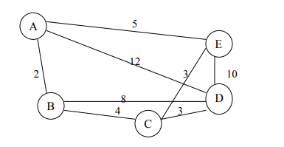

1. A more difficult TSP problem, the following matrix A represents the edge weight for a digraph (system), with 4 vertices. If a weight is not defined, then that path is not permissible.

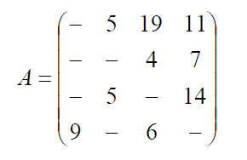

It is recommended to solve this problem by hand.

1. Find the minimum of the following problem (taken from <https://optimization.mccormick.northwestern.edu/index.php/Quadratic_programming>)

f(x)=3{x_1}^2+{x_2}^2+2{x_1}{x_2}+x_1+6{x_2}+2   
\text{s.t.} 2{x_1}+3{x_2} \ge 4   
{x_1},{x_2} \ge 0



Solve without the constraints (the s.t. meaning subject to) by hand first

(should find that x1\* = 5/4 and x2\* = -17/4 and f(x)\_min = -10.125)

Can you then implement in Matlab using quadprog with the constraints?

1. Learn about the Simplex Method and Slack variables. This is related to Gaussian elimination, and is a mechanism for solving linear programming problems by hand. Have a look online, and/or use the pdf document embedded here:

